**Port no. Changing::**

**1.Launch 1 ec2-instance**

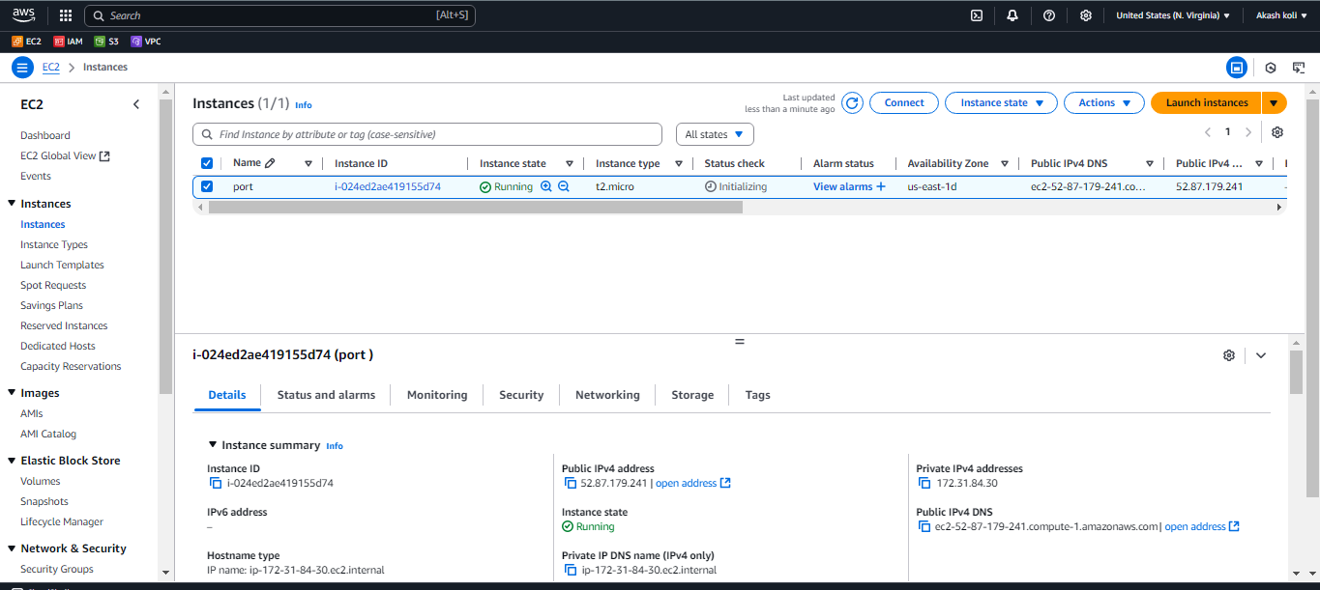

**2Connect &run commands for changing port no: default port=22**

**sudo su**

**vi /etc/ssh/sshd_config**

**systemctl restart sshd**

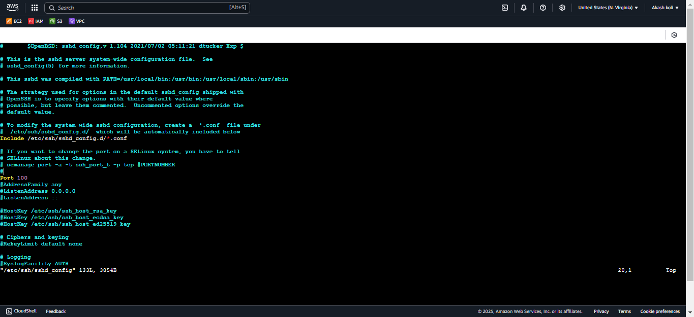

**3. Change the security group- inbound 100 port allow must**

**&connect through command prompt**

**ssh –i keyname.pem** [**ec2-user@pub.IP**](mailto:ec2-user@pub.IP) **–p 100**

